**PLC Setup:**

It’s important to know how to program a Click PLC to allow the Power Tools Test Manager to interface with it and operate controls. It will be assumed that the programmer is using, and familiar with, the free Click PLC Programming Software. A half-duplex RS-485 network is also assumed.

Firstly, the user must make sure that the PLC has its serial port configured correctly. Navigate to Setup – Com Port Setup – Port 3 Setup. Choose Modbus as the protocol. Next, the Node Address that you choose when programming the PLC must be unique from all other PLCs in the network, or errors will occur. Finally, the Baud Rate, Parity style, and amount of Stop Bits must be as they appear in the following menu, otherwise the PLC will not be able to communicate with the Test Manager software.

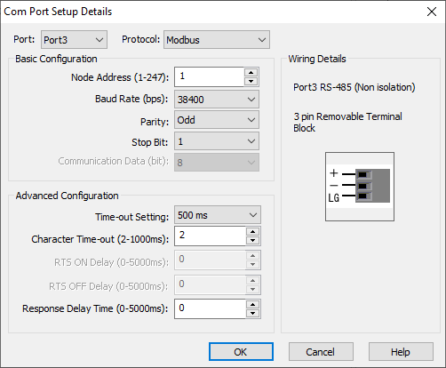

Next, the user should understand that Coil 50 (C50) is the pause coil. C50 being high should mean that the test is paused, and C50 being low should mean that the test is not paused. This coil should be configured to reflect the pause status of the test at all times. Additionally, setting or resetting C50 should be able to change the test controller into that status at any time. For example, it may be tempting to create a rung in the program that looks like this one:



However, this rung will make it so that even if C50 is changed by the controls in Test Manager, it will get changed back to whatever X1 is on the next cycle. This is bad, and will make it appear that the control buttons in Test Manager aren’t working. Instead, the programmer should use rungs like these:

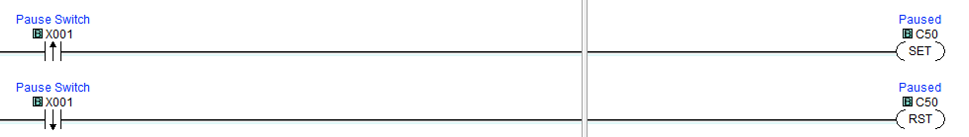

This way, the local pause controls will update C50 as normal, but C50 can also be updated to a new status from Test Manager.

The programmer should also know that any data that they would like to appear in Test Manager should be placed in the float registers DF101 – DF132. These are the only registers which are polled by Test Manager, but there should be plenty to hold any data required. As mentioned in the Test Manager tutorial, the contents of these registers will appear in the field numbered 100 less than the register address. For example, DF101 will appear if field 1 is enabled, DF102 will appear as field 2, etc.

Lastly, the programmer should know that any control coils that they would like to be available in Test Manager should be in the range from C101 – C132. These are the only coils that are polled by and accessed from Test Manager, besides the pause coil. These are mapped to numbers 1-32 in order, just like the data registers. Additionally, the programmer should configure rungs that set these coils the same way that they have been instructed to configure the pause related rungs.

**This concludes the Programming Guide.**

**Thank you again for using Snap-On Power Tools Test Manager.**